**Mongo DB Assignment**

**Query / Find Documents:**

**1.Get all documents**

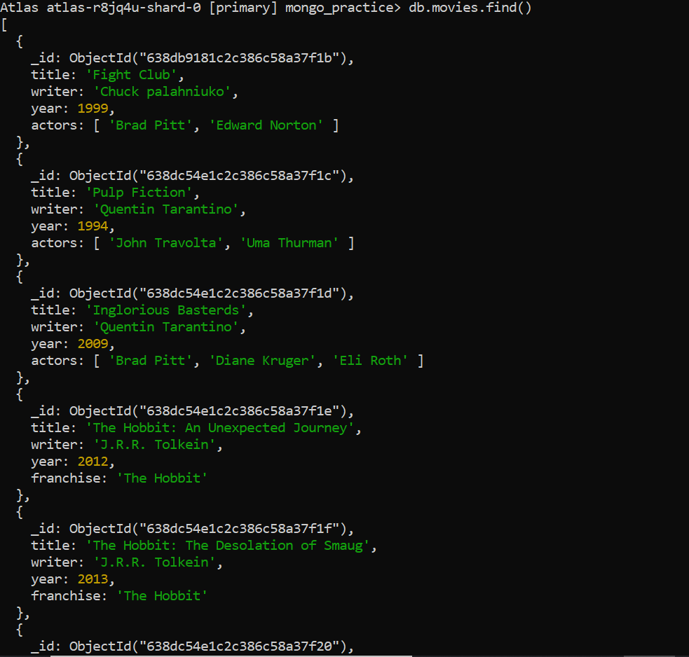

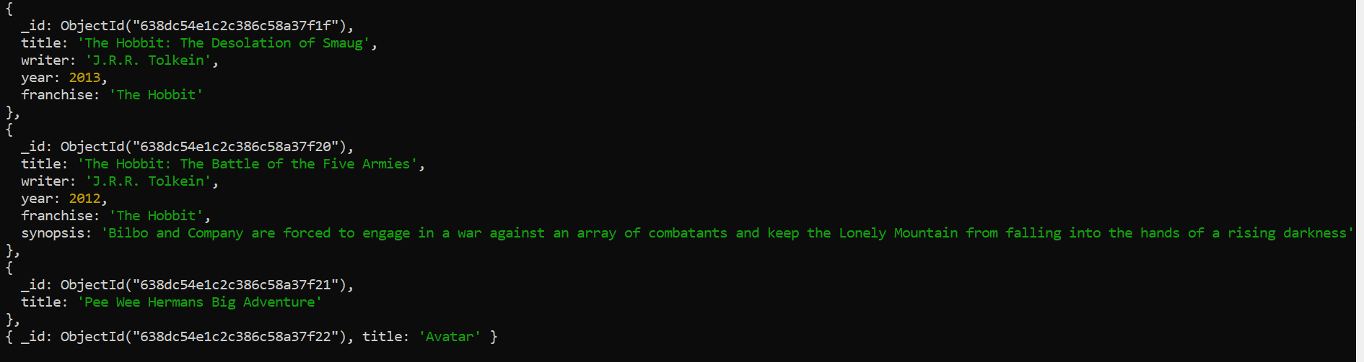

**2.Get all documents with writer set to “Quentin Tarantino”**

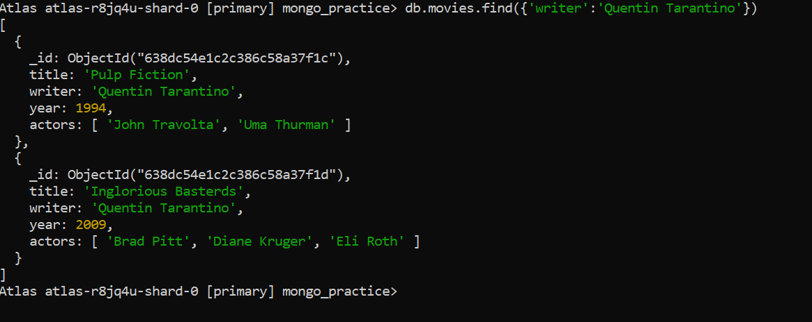

**3.Get all documents where actors include “Brad pitt”**

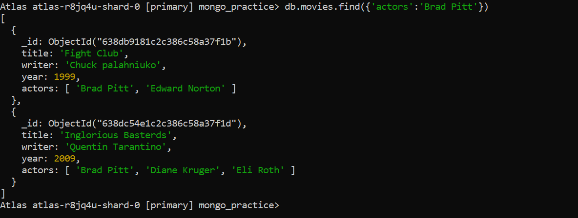

**4.Get all documents with franchise set to “The Hobbit”**

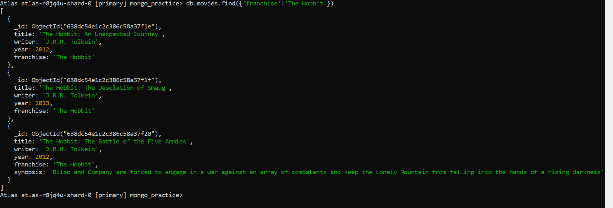

**5.Get all the movies released in 90’s**

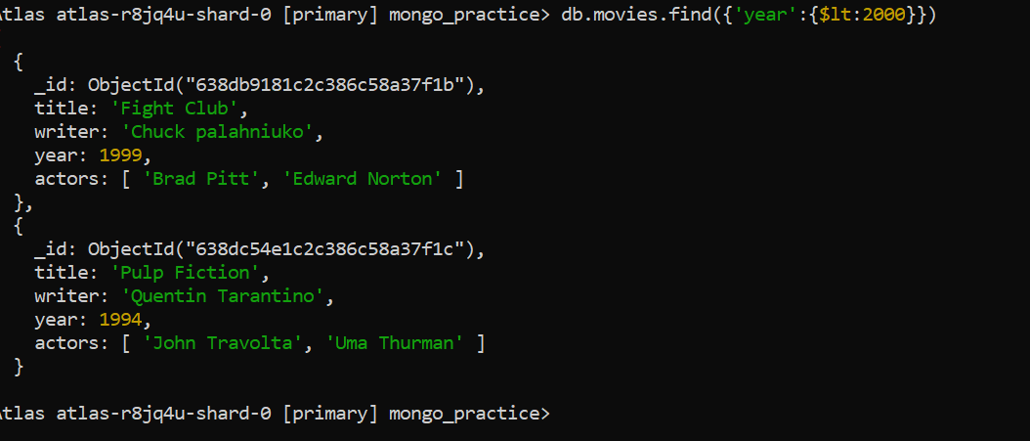

**6.Get all movies released before the year 2000 or after 2010**

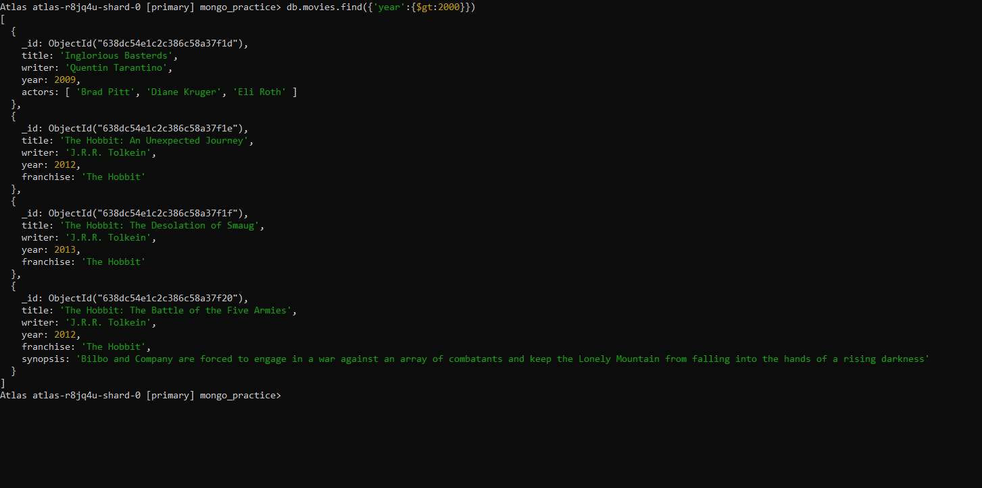

**Update Documents**

**1.**

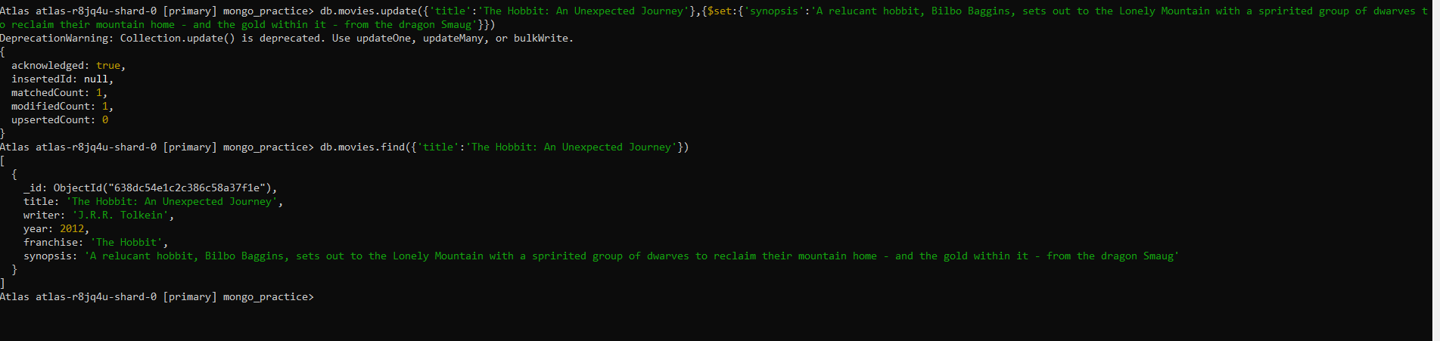

**2.**

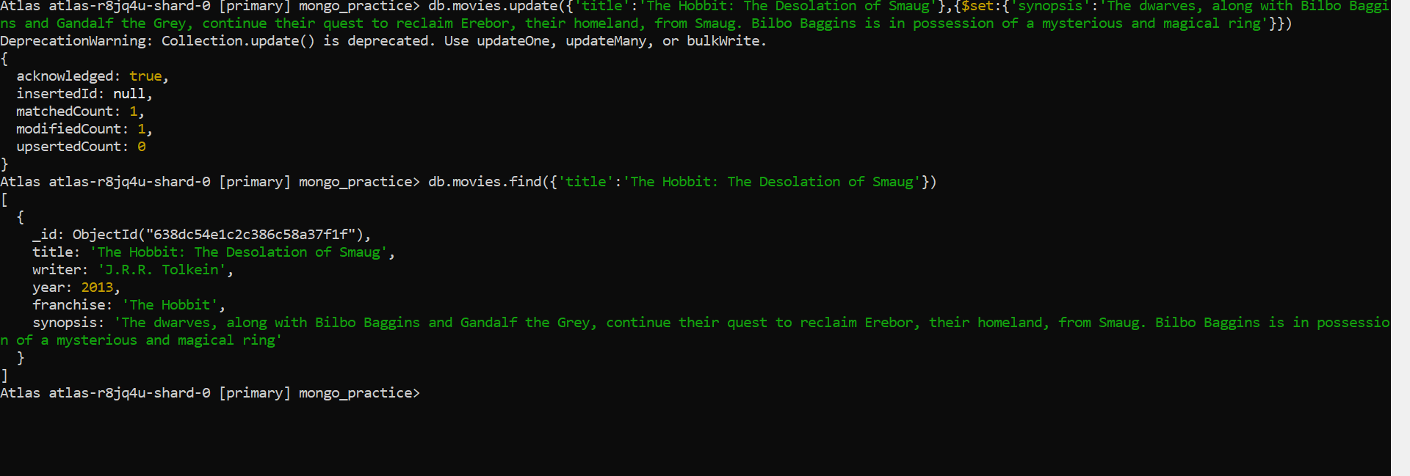

**3.**

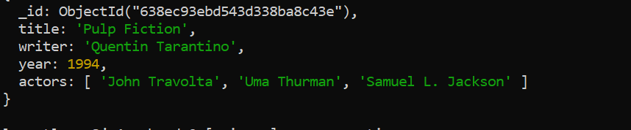

**Text Search**

**1.**

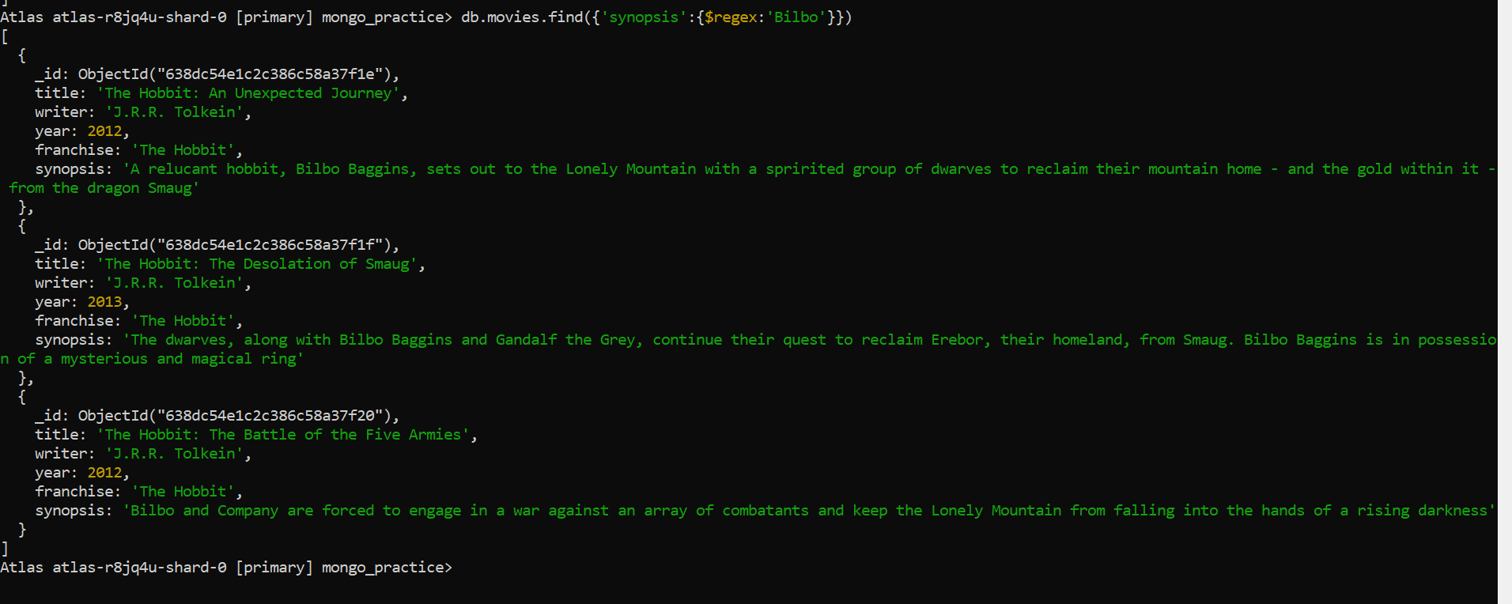

**2.**

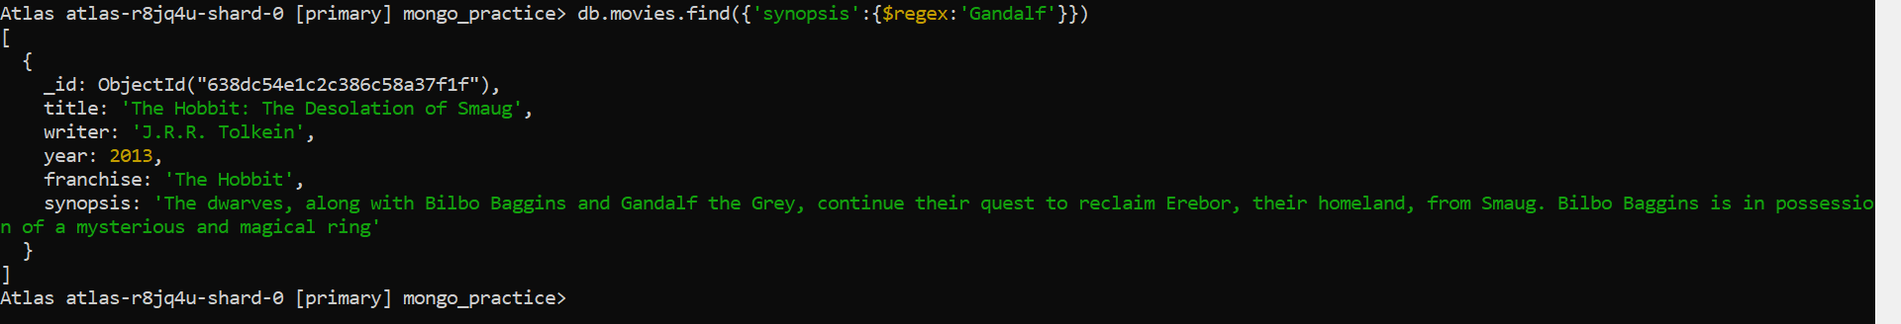

**3.**

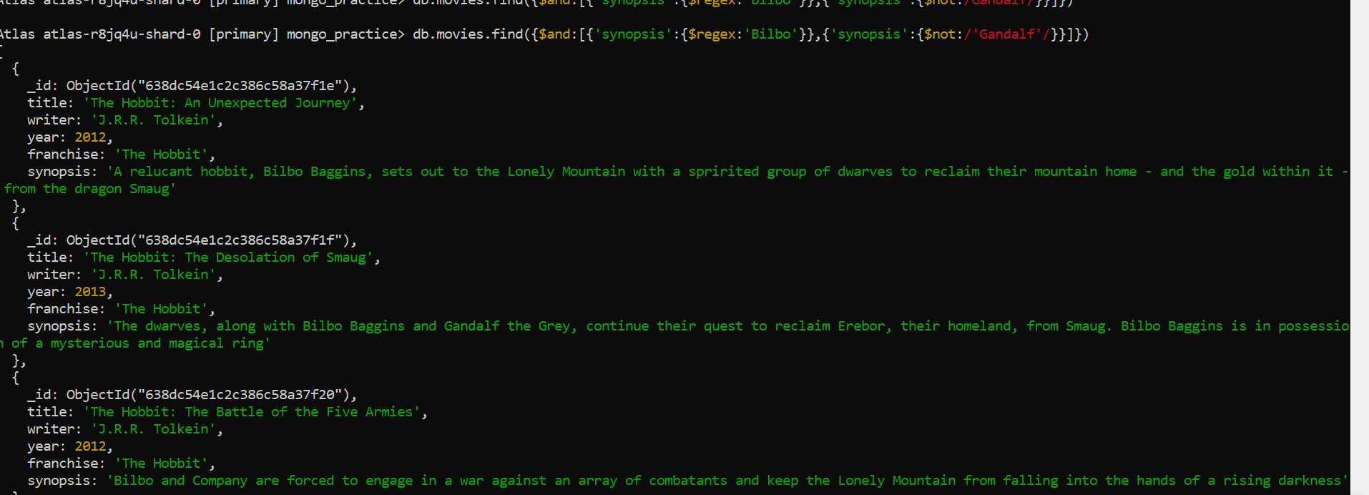

**4.**

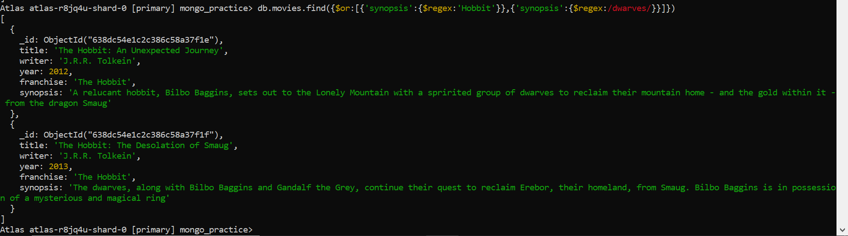

**5.**

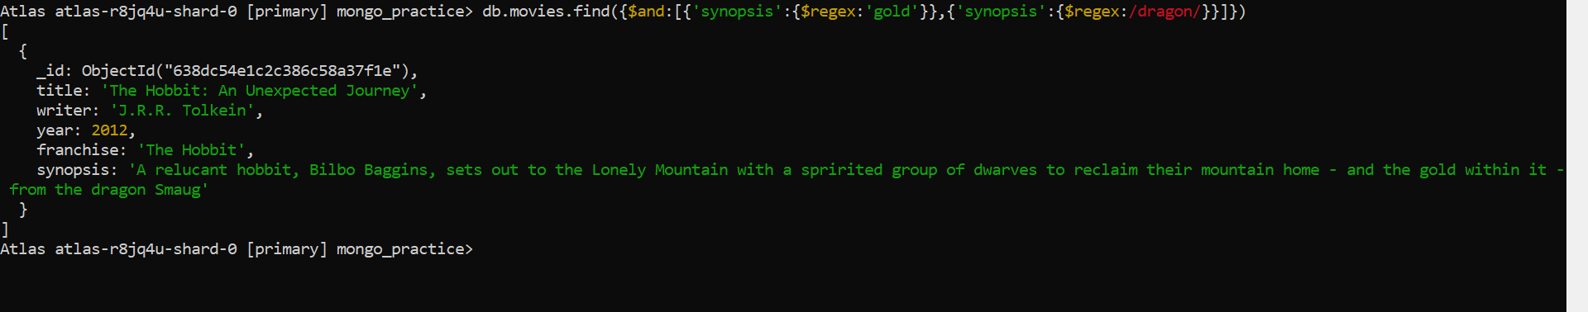

**Delete Documents**

**1.**



**2.**



**Relationships**

**1.**

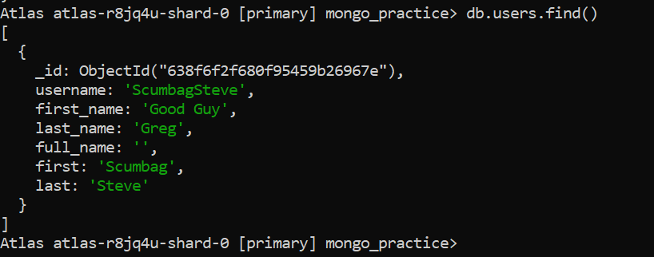

**2.**

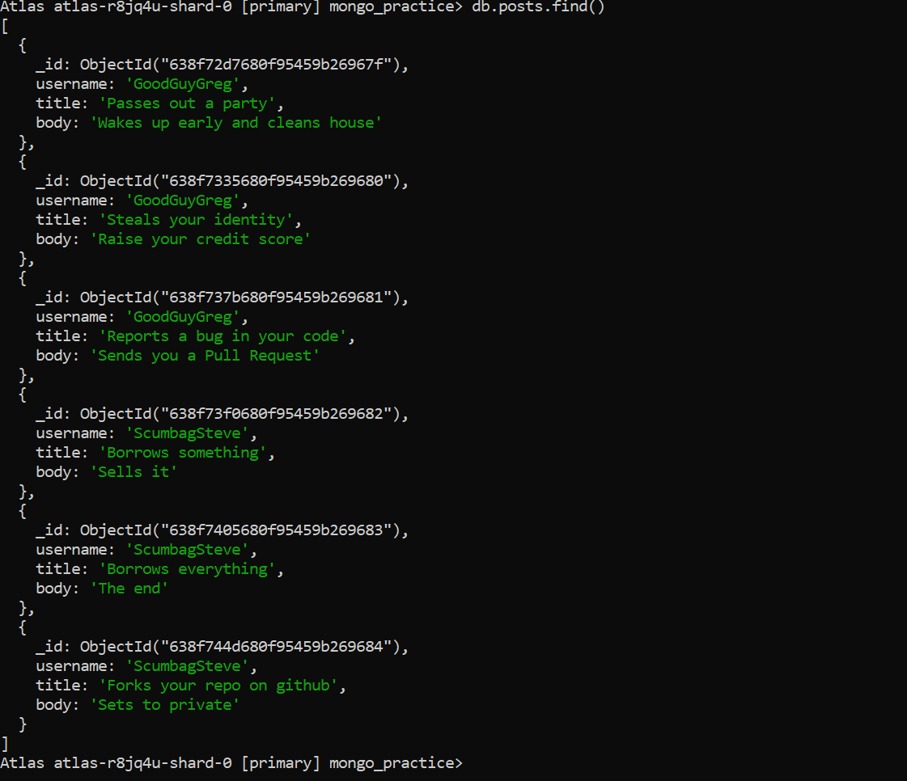

**3.**

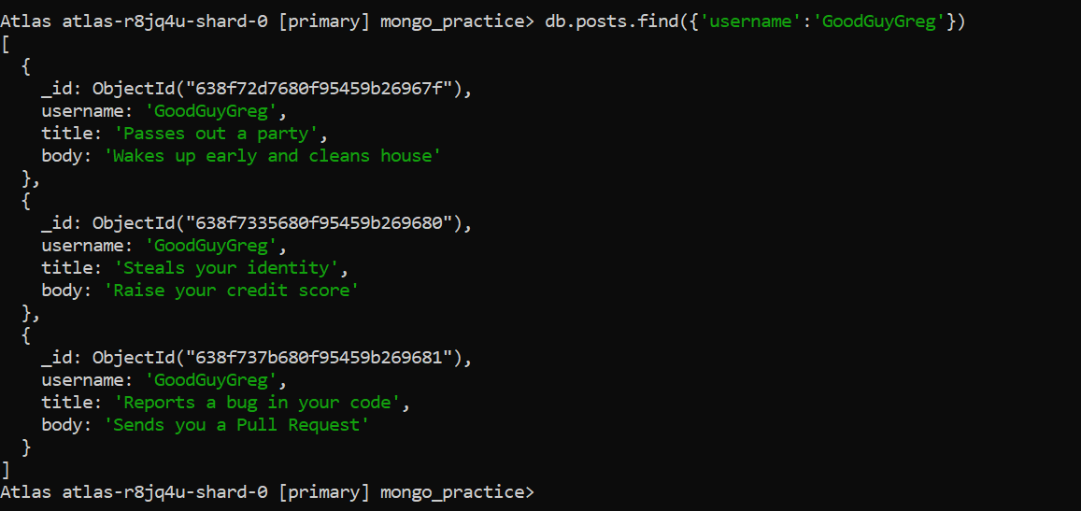

**4.**

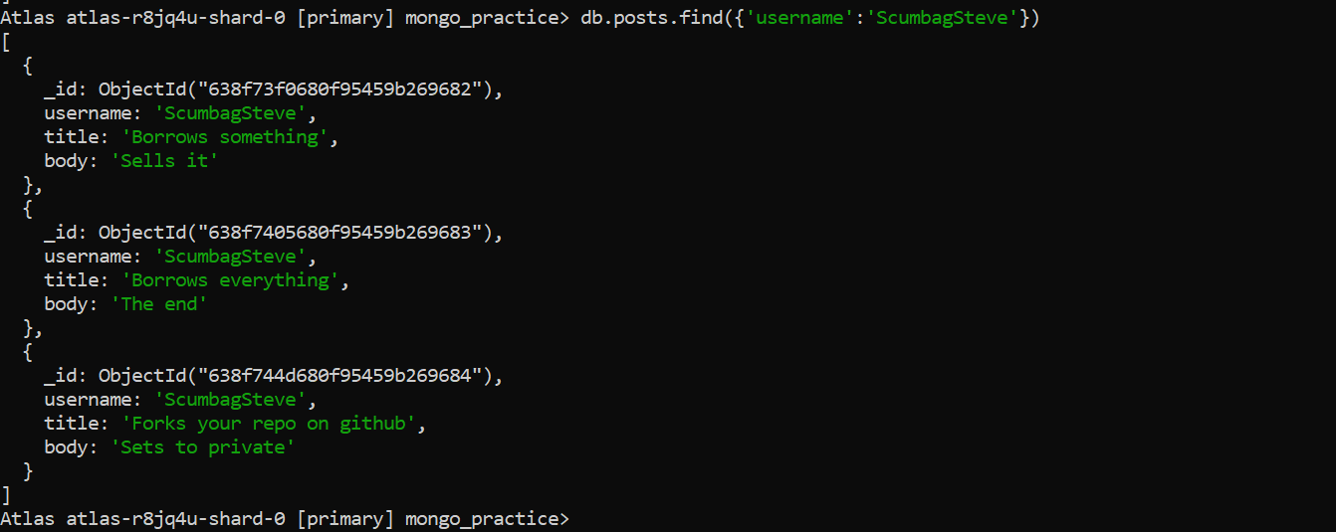

**5.**

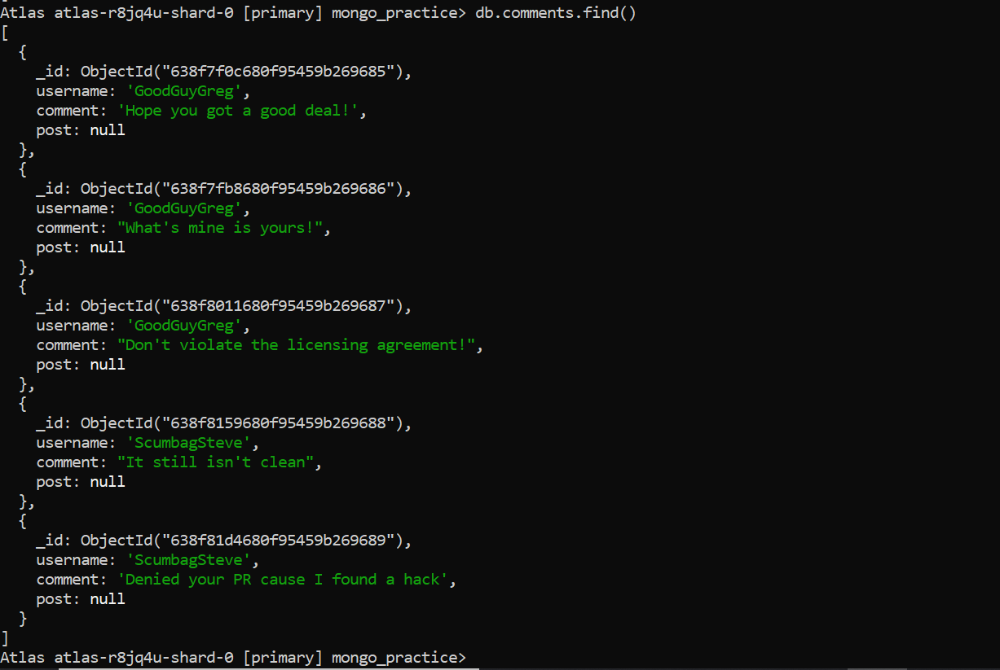

**6.**

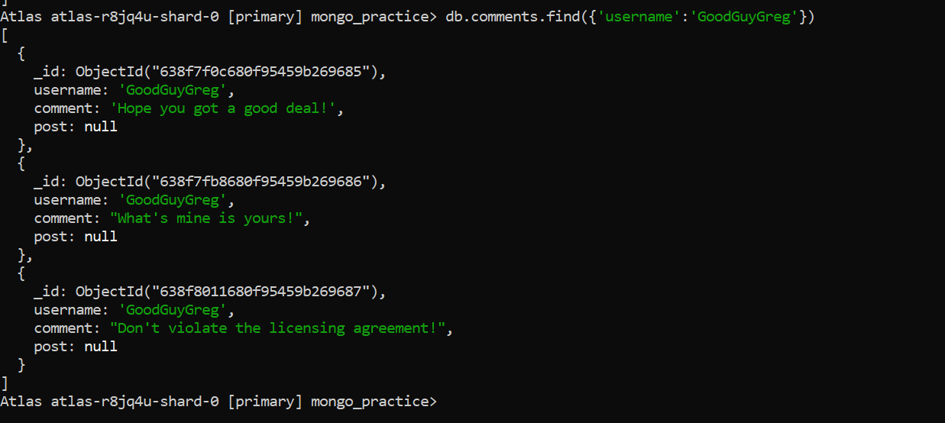

**7.**

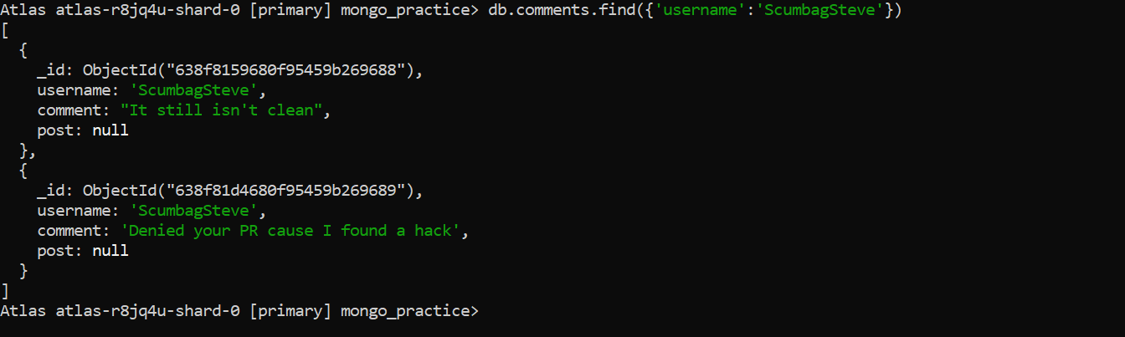

**8.**

